ONLINE DRUGSTORE SYSTEM

Requirements Specification and Analysis

Version 0.1

<16.11.2017>

Ertuğrul KOÇ

Çağla ÇINAR

Sefa KORKMAZ

Emre YILMAZ

Prepared for

SE301



Table of Contents

1. Introduction 1

1.1. Purpose of the System 1

1.2. Scope of the System 1

1.3. Objectives and Success Criteria of the Project 1

1.4. Definitions, Acronyms, and Abbreviations 1

1.5. Overview 2

2. Current System 2

3. Proposed System 3

3.1. Overview 3

3.2. Functional Requirements 3

3.3. Nonfunctional Requirements 4

3.4. System Models 5

**Scenarios** 5

**Use Cases** 15

Use Case Diagram of Drugstore System 29

Object model 30

Dynamic models 30

3.5. Project Schedule 48

4. Glossary 48

5. References 50

REQUIREMENTS ANALYSIS DOCUMENT

# Introduction

Briefly, Online Drugstore is online pharmacy system. It allows users to buy drugs easily which may or mayn’t are prescriptive. However, buying prescriptive drugs needs the prescription id. The doctors all need to do is adding the prescription into the system with relation with its patient.

## Purpose of the System

The aim of online Drug Store system provides simple interface for patient users to buy drugs that they need. The system is allows patients to buy drugs without going out to go to pharmacy. The system’s point, that makes difference between others, is allowing the users to buy drugs which are prescriptive.

## Scope of the System

Scope of the system is to create an easy environment that patients can buy drugs which they need. This is really significant benefit because if the patients can’t go out to go to pharmacy and have no friend to buy drugs that patients need or want. All patients should do is, opening the site and choosing the drug which they want or need and if the drug is prescriptive entering the prescription information then entering the location and payment information, before ordering the drugs. The doctor’s task is just entering the prescription information for patients.

## Objectives and Success Criteria of the Project

Online Drugstore System a basic system to order drugs. Ordering drug is the main objective that a patient can perform on the system. This objective has two part which are prescriptive drugs and non-prescriptive drugs. For non-prescriptive drugs patient just chooses the drugs and enters the required information (Location, payment), for prescriptive drugs, patient chooses the drugs enters the prescription information and required information. Furthermore, another object is checking the drugs for it needs prescription which are added by doctors or not. Success Criteria of the project that ordering the prescriptive drugs and non-prescriptive drugs.

## Definitions, Acronyms, and Abbreviations

RAD: Requirements Analysis Document

User: Patient

DS: Drugstore System

## Overview

Rest of the RAD contains more detailed info about the system, a functional overview of the system. Functionality of the system will be held detailed on the rest of the Rad. Also system models will be added carefully.

Rest of the RAD will be organized as follows.

This is the first version of our system, so we do not have an existing system which is running. Because of that how the tasks supported by the Drug Store system are accomplished now is explained in “Current System” title.

Documents the requirements elicitation and the analysis model of the new Drug Store system explained in under the title of “Proposed System”.

Functional overview of the system explained under the title of “Overview”.

The high-level functionality of the system described in the “Functional Requirements” section of the rad.

Describes user-level requirements that are not directly related to functionality of the system described in “Nonfunctional Requirements**”** section of the rad.

Examined subsections of system models which are scenarios, use cases, object model, and dynamic models for the system.

As its last references given under the title of “References”.

# Current System

There are a lot of drugstores around online world [1]. These sites could show all drugs and their users could choose and look at the all drugs and their information. Furthermore, they have cart function to buy drugs like all online shopping sites. They could also delete from cart some drugs. Then if users want to buy it they could buy drugs with considering the drugs are prescriptive or non-prescriptive. The fact that if the drug is prescriptive they want user to enter their prescription information. At the end, they sell the drugs with getting user’s credit card and location information.

The problem that we consider is easiness with interaction between doctor and prescriptions for users. In our system, doctor could register and login the system and has a profile. The point is doctor could manage the prescriptions currently.

# Proposed System

Briefly, in our system (DS), the system allows users to search and look at the drugs, then if users want to buy drugs, they could add the drugs to the cart and they also could delete drugs from cart. Later on, they could buy the drugs with considering that drugs are prescriptive or non-prescriptive with entering the prescription information then entering the credit card and location information. Furthermore, the system also allows doctor to do that listing the prescriptions, adding prescriptions, deleting prescriptions, managing prescriptions currently.

## Overview

The system will facilitate the patients’ process for buying drugs.

## Functional Requirements

***User Functional Requirements***

* **List of Drug**

User can see drug’s list .In this list, User can add to cart, delete from cart and search drug operations.

* **Authentication**

Users enter his/her required information into system to authenticate to the system. Users can’t access any function without authentication.

* **Buy**

User can buy drug

* **Log Off**

User exits the system when they finished the operations on the system.

***Admin Functional Requirements***

* **List Of Doctor**

Admin can see doctor’s list .In this list, Admin can add and delete operations.

* **List Of Drug**

Admin can see drug’s list .In this list, Admin can add, delete and update drug operations.

* **Approve Request of Doctor**

Admin displays incoming requests, and examine them. Admin accept or reject the requests

* **Log Off**

Admin exits the system when they finished the operations on the system.

* **Authentication**

Admin enter his/her required information into system to authenticate to the system. Admin can’t access any function without authentication.

***Doctor Functional Requirements***

* **List Of Prescription**

Doctor can see prescription’s list .In this list, Doctor can add and delete operations.

* **Log Off**

Doctor exits the system when they finished the operations on the system.

* **Authentication**

Doctor enters his/her required information into system to authenticate to the system. Doctor can’t access any function without authentication.

* **Register Doctor**

The doctor must first register to access the system.

## Nonfunctional Requirements

**3.3.1 Usability**

|  |
| --- |
| **Function Description** |
| The user can buy drug in 2-3 steps. |
| User will see price and prospectus. |
| Responds to users' reuest as soon as possible. |

**3.3.2 Performance**

|  |
| --- |
| **Function Description** |
| User can send update message to admin. |
| Admin should check the system continuously |

**3.3.3 Supportability**

|  |
| --- |
| **Function Description** |
| The user must receive a warning indicating the end of the measurement. |
| Mobile application should not be complicated for the user to use it easily. |

**3.3.4 Implementation**

* The Database is implemented in MySql WorkBench 6.3 CE.
* The code part is done with NetBeans IDE 8.2.

**3.3.5 Legal**

* For users the system is free to use.

## System Models

**Scenario 1**

|  |
| --- |
| **Scenario name:** Register |
| **Participant actor instances: Kamil: User** |
| **Flow of events:**   1. Kamil opens the web site 2. Kamil clicks on the register button to be member. 3. Kamil sees the register page and he enter Kamilname into Kamilname text field also enter password into Password text field, email into email text field on this page.   a) If Kamil leaves one or more fields empty, system displays a warning message, like "This area cannot be empty."  b) If Kamilname is unique and password is suitable Kamil can register the system.  Kamil registered the system. |

**Scenario 2**

|  |
| --- |
| **Scenario name:** Login |
| **Participant actor instances: Kamil: User** |
| **Flow of events:**   1. Kamil opens the web site 2. Kamil clicks on the login button. 3. Kamil sees login pages and he enters Kamilname into Kamilname text field also enter password into Password text field on this pages.   a) If Kamil leaves one or more fields empty, system displays a warning message, like "This area cannot be empty."   1. The Kamilname, password match to information which is in Drug’s database Kamil can login to the Drug System. 2. If the information’s checked from database are not true, system displays a warning message, like "Wrong Kamilname or password, please retry." |

**Scenario 3**

|  |
| --- |
| **Scenario name:** Searching the drugs |
| **Participant actor instances: Kamil: User** |
| **Flow of events:**   1. Kamil opens the web site 2. System shows the main page 3. Kamil clicks on the search input field. 4. Kamil writes the name of drug that he wants to look at. 5. Kamil clicks on the search button to search that he wrote. 6. System shows the list of drugs that represents the searched thing from database. 7. Kamil sees the results |

**Scenario 4**

|  |
| --- |
| **Scenario name:** Clicking the add to cart button for drug |
| **Participant actor instances: Kamil: User(Not logged in)** |
| **Flow of events:**   1. Kamil opens the web site 2. System shows the main page 3. Kamil finds and clicks on the drug. 4. System shows the drug information. 5. Kamil clicks on the “add to cart” button. 6. System makes him to direct to login page. |

**Scenario 5**

|  |
| --- |
| **Scenario name:** Adding to cart |
| **Participant actor instances: Kamil: User** |
| **Flow of events:**   1. Kamil opens the web sites. 2. System shows the home page 3. Kamil clicks the login button and fills the Kamilname and password fields. 4. System checks the information between filled and database, and make Kamil to be logged in. 5. Kamil clicks on the drug. 6. System shows the drugs information. 7. Kamil clicks on the add to cart button. 8. If the buying the drug needs a prescription  * System show the prescription id input field * Kamil enters the prescription id of the drug. * System checks the id of prescription from database.  1. System added the drug to cart. |

**Scenario 6**

|  |
| --- |
| **Use case name:** Logout |
| **Participant actors: Kamil: User** |
| **Flow of events:**   1. Kamil clicks "Logout" button. 2. System redirects user to the login page. |

**Scenario 7**

|  |
| --- |
| **Scenario name:** Cancelling drugs from the cart |
| **Participant actor instances: Kamil: User** |
| **Flow of events:**   1. Kamil opens the website. 2. System shows the home page. 3. Kamil adds some drugs to cart(Or some drugs were added before) 4. Kamil clicks the cart button. 5. System shows the cart page of him or her. 6. Kamil click on the delete drug button for one of the drugs that were added to cart 7. System deletes the drugs from cart. |

**Scenario 8**

|  |
| --- |
| **Scenario name:** Buying the Drug |
| **Participant actor instances: Kamil: User** |
| **Flow of events:**   1. Kamil opens the website. 2. System shows the home page. 3. Kamil adds some drugs to cart(Or some drugs were added before) 4. Kamil clicks the cart button. 5. System shows the cart page of him or her. 6. Kamil click on the “continue shopping button” to continue 7. System shows the location and credit cards input fields’ page. 8. Kamil enters the location and credit card information. 9. Kamil enters the finish shopping button. 10. System checks the information and all fields are not empty. 11. System shows the message “shopping is finished successfully”. |

**Scenario 9**

|  |
| --- |
| **Scenario name:** Login Admin |
| **Participant actor instances: Admin:Emre** |
| **Flow of events:**   1. Firstly Emre writes Drugstore System/admin on browser. 2. Emre sees login pages and she enter Username into Username text field also enter password into Password text field on this pages.   a) If Emre leaves one or more fields empty, system displays a warning message, like "This area cannot be empty."   1. If Username, password and role match to information which are in Drugstore database Emre can login to the Drugstore System.   a)If the information checked from database are not true, system displays a warning message, like "Wrong username or password, please retry.". |

**Scenario 10**

|  |
| --- |
| **Scenario name:** Adding Doctor |
| **Participant actor instances: Admin: Emre Doctor: Çağla** |
| **Flow of events:**   1. Emre hears that Çağla want to add prescription in the Drugstore System. 2. Firstly Emre logs into the Drugstore System. 3. Emre selects “Add New Doctor” button. 4. Emre fills the related field with the personal information of the Çağla. 5. Then Emre click “save” button. 6. Drugstore System saves the Çağla’s personal information on database. 7. Emre sees a “Saved successfully" message on screen. Then Emre logs of. |

**Scenario 11**

|  |
| --- |
| **Scenario name:** Deleting Doctor |
| **Participant actor instances: Admin:**Emre **Doctor:** Çağla |
| **Flow of events:**   1. Emre hears that Çağla wants to delete her account. 2. Firstly Emre logs into the DS. 3. Emre selects “Delete Doctor” button 4. He sees all Doctor who registered in the system. 5. Emre chooses Çağla. 6. Then Emre click “delete and save” button. 7. Drugstore finds the Çağla on database and delete her all information on system. 8. The message shown on screen that “The doctor is deleted successfully”. 9. Emre logs of. |

**Scenario 12**

|  |
| --- |
| **Scenario name:** Approve Request of Doctor |
| **Participant actor instances: Admin:**Emre **Doctor**: Çağla |
| **Flow of events:**   1. Firstly Çağla logs into the DS. 2. Çağla send request to be instructor to Emre. 3. Emre clicks the "Request of Doctors" button. 4. Emre sees List of Requests of Doctors. 5. Emre chooses Çağla’s name and click Approve button. 6. Emre clicks the "Save" button or “Don’t Save” button. 7. Emre see a "Saved successfully!" or "Saved is not successfully!" message on a dialogue box. 8. Emre logs of. |

**Scenario 13**

|  |
| --- |
| **Scenario name:** List Of Doctor |
| **Participant actor instances: Admin:**Emre |
| **Flow of events:**   1. Firstly Emre logs into the DS. 2. Emre clicks the "List Doctor" button on administrator main page. 3. He sees all Doctors who registered in the system. 4. Emre clicks "Back" button. 5. The system directs administrator to his/her main page. 6. Emre logs of. |

**Scenario 14**

|  |
| --- |
| **Scenario name:** List Of Drug |
| **Participant actor instances: Admin:**Emre |
| **Flow of events:**   1. Firstly Emre logs into the DS. 2. Emre clicks the "List Drug" button on administrator main page. 3. He sees all Drugs who saved in the system. 4. Emre clicks "Back" button. 5. The system directs administrator to his/her main page. 6. Emre logs of. |

**Scenario 15**

|  |
| --- |
| **Scenario name:** Adding Drug |
| **Participant actor instances: Admin: Emre** |
| **Flow of events:**   1. Firstly Emre logs into the Drugstore System. 2. Emre selects “Add New Drug” button. 3. Emre fills the related field with the information about Drug. 4. Then Emre click “save” button. 5. Drugstore System save the drug’s information on database. 6. Emre sees a “Saved successfully" message on screen. 7. Emre logs of. |

**Scenario 16**

|  |
| --- |
| **Scenario name:** Deleting Drug |
| **Participant actor instances: Admin:**Emre |
| **Flow of events:**   1. Firstly Emre logs into the DS. 2. Emre selects “Delete Drug” button 3. He sees all Drug who in the system. 4. Emre chooses Drug to delete. 5. Then Emre click “delete and save” button. 6. Drugstore finds that drug on database and deletes it’s all information on system. 7. The message shown on screen that “The drug is deleted successfully”. 8. Emre logs of. |

**Scenario 17**

|  |
| --- |
| **Use case name:** Logout |
| **Participant actor instances: Admin:**Emre |
| **Flow of events:**   1. Emre clicks "Logout" button. 2. System redirects administrator to the login page. |

**Scenario 18**

|  |
| --- |
| **Scenario name:** Update Drug |
| **Participant actor instances: Admin:**Emre |
| **Flow of events:**   1. This event starts with Emre click to the update Drug button. 2. System directs Emre to drug page. 3. Emre updates drug information’s 4. Emre click’s done. 5. System updates drug information and database. |

**Scenario 19**

|  |
| --- |
| Scenario name: Doctor’s Register |
| Participant actor instances: Çağla: Doctor |
| Flow of events:   1. Firstly Çağla enters [www.drugStore.com](http://www.drugstore.com/) on browser. 2. Drugstore welcomes Çağla with main page. Çağla sees register button below the login fields and clicks register. 3. She will be directed to register page after click for choose register as an doctor. 4. After choosing register as an doctor she will be directed to doctor register fields to fill. 5. Çağla fills field with information needed. 6. Çağla clicks done. 7. Account is created. |

**Scenario 20**

|  |
| --- |
| Scenario name: Doctor’s Login |
| Participant actor instances: Çağla: Doctor |
| Flow of events:   1. Firstly Çağla enters [www.drugStore.com](http://www.drugstore.com/) on browser. 2. Drugstore welcomes Çağla with main page. Çağla sees login button and Çağla fills the login fields and clicks login button. 3. If SSN and password matches with database she accesses her account. |

**Scenario 21**

|  |
| --- |
| Scenario name: Create Prescription |
| Participant actor instances: Çağla: Doctor |
| Flow of events:   1. This event starts with Çağla’s click to the create a new prescription button. 2. Çağla is directed to the create prescription page. 3. Çağla fills the prescription information. 4. Çağla clicks done. 5. Prescription is added to the Drugstore Systems. |

**Scenario 22**

|  |
| --- |
| Scenario name: List Prescription |
| Participant actor instances: Çağla: Doctor |
| Flow of events:   1. This event starts with Çağla’s click to the list prescriptions button after opened prescription page. 2. System shows to Çağla prescriptions list. 3. Çağla clicks “back” button. 4. The system direct doctor’s main page. |

**Scenario 23**

|  |
| --- |
| Scenario name: Delete Prescription |
| Participant actor instances: Çağla: Doctor |
| Flow of events:   1. This event starts with Çağla’s click to the delete prescription button after opened prescriptions list. 2. Çağla select a prescription. 3. Çağla clicks “delete prescription” button. 4. Prescription is deleted from prescription list, database updated. |

**Scenario 24**

|  |
| --- |
| Scenario name: Update Doctor Information |
| Participant actor instances: Çağla: Doctor |
| Flow of events:   1. This event starts with Çağla’s click to the update doctor profile button. 2. Systems direct Çağla’s to profile page. 3. Çağla updates profile information. 4. Çağla clicks done. 5. System updates profile information and database. |

**Use Case 1**

|  |
| --- |
| **Use case name:** Login |
| **Participant actors:** Initiated by Admin |
| **Flow of events:**   1. Admin displays the login screen of the application. 2. Admin enters username and password to the related areas. 3. Admin clicks "Login" button. 4. System checks the information from database. 5. System fetches the main screen of administrator. |
| **Entry Condition:**-Admin displays the login screen of the system.  -Admin saves his/her information to the database. |
| **Exit Condition:** Admin clicks "Login" button and system displays the admin main page. |
| **Quality Requirements**: - If admin leaves one or more fields empty, system displays a warning message, like "This area cannot be empty."  -If the information checked from database are not true, system displays a warning message, like "Wrong username or password, please retry." |

**Use Case 2**

|  |
| --- |
| **Use case name:** Add Doctor |
| **Participant actors:** Initiated by Admin |
| **Flow of events:**   1. Admin clicks "Add New Doctor" button. 2. System fetches the screen that new personnel can be added. 3. Admin fills the related areas with the personal information of the new doctor.   a) If admin leaves a field empty, system displays a warning message, like "This area cannot be empty."   1. Admin clicks "Save" button.   a) If admin closes the page without saving, system does not save the information.   1. System saves the new doctor and his/her information to the database. 2. System displays a "Saved successfully!" message on a dialogue box.   a) If system fails to save information to the database, it displays a "saving is unsuccessful" message   1. System redirects admin to the admin main page. |
| **Entry Condition:** Admin logs in to the Drug Store System.  Admin displays his/her main page. |
| **Exit Condition:** System saves the new personnel and his/her information to the database, then system displays a "Saved successfully!" message and system redirects admin to the admin main page. |
| **Quality Requirements:** - If admin leaves a field empty, system displays a warning message, like "This area cannot be empty."  -If admin closes the page without saving, system does not save the information.  -If system fails to save information to the database, it displays a "saving is unsuccessful" message. |

**Use Case 3**

|  |
| --- |
| **Use case name:** Delete Doctor |
| **Participant actors:** Initiated by Admin |
| **Flow of events:**   1. Admin selects a doctor that is going to be deleted.   a) If admin does not select a doctor from doctor list, system displays a warning message, like "A selection must be done to delete"   1. Admin clicks the "Delete Doctor" button. 2. System deletes the selected doctor record from database. 3. System displays a "Deleted successfully!" message on a dialogue box.   a) If system fails to delete information from the database, it displays a "deleting is unsuccessful" message.   1. System reloads the doctor list screen. |
| **Entry Condition:**-Admin logs in to the Drugstore System.  -Admin displays the screen that list of doctor is displayed. |
| **Exit Condition:** System displays a "Deleted successfully!" message and system reloads the doctor list screen. |
| **Quality Requirements:** -If admin does not select a doctor from doctor list, system displays a warning message, like "A selection must be done to delete".  - If system fails to delete information from the database, it displays a "deleting is unsuccessful" message. |

**Use Case 4**

|  |
| --- |
| **Use case name:** Approve Request of Doctor |
| **Participant actor instances:** Initiated by Administrator |
| **Flow of events:**   1. Admin clicks the "Request of Doctor" button. 2. System shows List of Requests of Doctor. 3. Admin choose doctor name and click "Approve" button. 4. Admin clicks the "Save" button. 5. System shows a "Saved successfully!" message on a dialogue box. |
| **Entry Condition:** Admin logs in to the Drugstore System.  Admin displays his/her main page. |
| **Exit Condition:** Admin clicks "Logout" button and system redirects admin to the login page. |
| **Quality Requirements:** -If admin does not select any request of doctor, and click approve system displays a warning message, like "You should choose a request".  - If admin closes the page without saving, system does not save the information.  - If system fails to save information to the database, it displays a "saving is unsuccessful" message. |

**Use Case 5**

|  |
| --- |
| **Use case name:** List Of Doctor |
| **Participant actors:** Initiated by Admin |
| **Flow of events:**   1. Admin clicks the "List Doctor" button on admin main page. 2. System fetches the screen which list of doctor can be displayed. 3. Admin clicks "Back" button. 4. The system directs admin to his/her main page. |
| **Entry Condition:** Admin logs in to the Examination System.  Admin displays his/her main page. |
| **Exit Condition:** Admin clicks "Back" button and system directs admin to his/her main page. |
| **Quality Requirements:** None. |

**Use Case 6**

|  |
| --- |
| **Use case name:** List of Drug |
| **Participant actors:** Initiated by Admin |
| **Flow of events:**   1. Admin clicks the "List Drug" button on admin main page. 2. System fetches the screen which list of drug can be displayed. 3. Admin clicks "Back" button. 4. The system directs admin to his/her main page. |
| **Entry Condition:** Admin logs in to the Drugstore System.  Admin displays his/her main page. |
| **Exit Condition:** Admin clicks "Back" button and system directs admin to his/her main page. |
| **Quality Requirements:** None. |

**Use Case 7**

|  |
| --- |
| **Use case name:** Add Drug |
| **Participant actors:** Initiated by Admin |
| **Flow of events:**   1. Admin clicks "Add New Drug" button. 2. System fetches the screen that new personnel can be added. 3. Admin fills the related areas with the personal information of the new drug.   a) If admin leaves a field empty, system displays a warning message, like "This area cannot be empty."   1. Admin clicks "Save" button.   a) If admin closes the page without saving, system does not save the information.   1. System saves the new drug and his/her information to the database. 2. System displays a "Saved successfully!" message on a dialogue box.   a) If system fails to save information to the database, it displays a "saving is unsuccessful" message   1. System redirects admin to the admin main page. |
| **Entry Condition:** Admin logs in to the Drug Store System.  Admin displays his/her main page. |
| **Exit Condition:** System saves the new personnel and his/her information to the database, then system displays a "Saved successfully!" message and system redirects admin to the admin main page. |
| **Quality Requirements:** - If admin leaves a field empty, system displays a warning message, like "This area cannot be empty."  -If admin closes the page without saving, system does not save the information.  -If system fails to save information to the database, it displays a "saving is unsuccessful" message. |

**Use Case 8**

|  |
| --- |
| **Use case name:** Delete Drug |
| **Participant actors:** Initiated by Admin |
| **Flow of events:**   1. Admin selects a drug that is going to be deleted.   a) If admin does not select a drug from drug list, system displays a warning message, like "A selection must be done to delete"   1. Admin clicks the "Delete Drug" button. 2. System deletes the selected drug record from database. 3. System displays a "Deleted successfully!" message on a dialogue box.   a) If system fails to delete information from the database, it displays a "deleting is unsuccessful" message.   1. System reloads the doctor list screen. |
| **Entry Condition:**-Admin logs in to the Drugstore System.  -Admin displays the screen that list of doctor is displayed. |
| **Exit Condition:** System displays a "Deleted successfully!" message and system reloads the doctor list screen. |
| **Quality Requirements:** -If admin does not select a drug from drug list, system displays a warning message, like "A selection must be done to delete".  - If system fails to delete information from the database, it displays a "deleting is unsuccessful" message. |

**Use Case 9**

|  |
| --- |
| **Use case name:** Logout |
| **Participant actors:** Initiated by Admin |
| **Flow of events:**   1. Admin clicks "Logout" button. 2. System redirects admin to the login page. |
| **Entry Condition:** Admin logs in to the Drugstore System.  Admin displays his/her main page. |
| **Exit Condition:** Admin clicks "Logout" button and system redirects admin to the login page. |
| **Quality Requirements:** None. |

**Use Case 10**

|  |
| --- |
| **Use case name:** Update Drug |
| **Participant actors:** Initiated by Admin |
| **Flow of events:**   1. Admin selects a drug that is going to be update.   a) If admin does not select a drug from drug list, system displays a warning message, like "A selection must be done to edit".   1. Admin clicks the "Update Drug Information" button. 2. System fetches the screen that displays the information of selected personnel. 3. Admin changes necessary areas with the drug information of the selected drug.   a) If admin leaves a field empty, system displays a warning message, like "This area cannot be empty."   1. Admin clicks the "Save" button.   a) If admin closes the page without saving, system does not save the information.   1. System saves the changes to the database. 2. System displays a "Saved successfully!" message on a dialogue box.   a) If system fails to save information to the database, it displays a "saving is unsuccessful" message.   1. System redirects admin to the admin main page. |
| **Entry Condition:** Admin logs in to the Examination System.  Admin displays the screen that list of drug is displayed. |
| **Exit Condition:** System saves the changes to the database and displays a "Saved successfully!" message, then redirects admin to the admin main page |
| **Quality Requirements:** - If admin does not select a drug from drug list, system displays a warning message, like "A selection must be done to update".  - If admin leaves a field empty, system displays a warning message, like "This area cannot be empty."  - If admin closes the page without saving, system does not save the information.  - If system fails to save information to the database, it displays a "saving is unsuccessful" message. |

**Use Case 11**

|  |
| --- |
| Use Case Name: Register Doctor |
| Participant actor instances: Doctor |
| Flow of events:   1. Firstly doctor enters [www.drugStore.com](http://www.drugstore.com/) on browser. 2. Drugstore welcomes doctor with main page. Doctor sees register button below the login fields and click register. 3. Doctor will be directed to register page after click for choose register as a doctor. 4. After choosing register as a doctor, doctor will be directed to doctor register fields to fill. 5. Doctor fills field with information needed. 6. Doctor click done button. 7. Account is created by systems. |
| Entry Condition: Doctor should enter the register page. |
| Exit Condition: Account is created. |
| Quality Requirement:  1. System response to the actor arrives in a few seconds. |

**Use Case 12**

|  |
| --- |
| Use Case Name: Login Doctor |
| Participant actor instances: Doctor |
| Flow of events:   1. Firstly doctor enters [www.drugStore.com](http://www.drugstore.com/) on browser. 2. Drugstore welcomes doctor with main page. Doctor sees login button and doctor fills the login field and clicks login button. 3. If SSN and password matches with database doctor accesses doctor account. |
| Entry Condition: Doctor should enter login page. |
| Exit Condition: Doctor login the system. |
| Quality Requirement:  1. System response to the actor arrives in a few seconds. |

**Use Case 13**

|  |
| --- |
| Use Case Name: Create New Prescription |
| Participant actor instances: Doctor |
| Flow of events:   1. This event starts with Doctor’s click to the Create a new prescription button. 2. Doctor is directed to the create prescription page. 3. Doctor fills the prescription information. 4. Doctor clicks done. 5. Prescription is added to the database. |
| Entry Condition: Doctor should be logged on as admin. |
| Exit Condition: Prescription is created. |
| Alternative flow:  1. Doctor lefts page without click done.  2. System cancelled function automatically. |
| Quality Requirement:  1. System response to the actor arrives in a few seconds. |

**Use Case 14**

|  |
| --- |
| Use Case Name: List Prescription |
| Participant actor instances: Doctor |
| Flow of events:   1. This event starts with Doctor’s click to the list prescription button after opened prescriptions page. 2. System shows to Doctor Prescription list. |
| Entry Condition: Doctor should be logged on as admin. And also should already create a prescription. |
| Exit Condition: A prescription is added to prescriptions list. |
| Quality Requirement:   1. System response to the actor arrives in a few seconds. 2. List is showed in alphabetic order. |

**Use Case 15**

|  |
| --- |
| Use Case Name: Delete Prescription |
| Participant actor instances: Doctor |
| Flow of events:   1. This event starts with Doctor’s click to the delete prescription button. 2. System directs Doctor to prescriptions page. 3. Doctor first selects a prescription. 4. Doctor clicks delete button. 5. System deletes prescription from the prescriptions and database. |
| Entry Condition: Doctor should be created a prescription. |
| Exit Condition: A prescription is deleted from Doctor. |
| Quality Requirement:  1. System response to the actor arrives in a few seconds. |

**Use Case 16**

|  |
| --- |
| Use Case name: Update Doctor Information |
| Participant actor instances: Doctor |
| Flow of events:   1. This event starts with Doctor’s click to the update profile button. 2. System directs Doctor to profile page. 3. Doctor updates profile information (Change of title etc.). 4. Doctor clicks done. 5. System updates profile information and database. |
| Entry Condition: Doctor should be login. |
| Exit Condition: Profile is updated. |
| Quality Requirement:  1. System response to the actor arrives in a few seconds. |

**Use Case 17**

|  |
| --- |
| **Use case name:** User Login |
| **Participant actors:** Initiated by User |
| **Flow of events:**   1. User opens the site. 2. System responds by displaying the login screen of the site. 3. User enters username and password to the login fields. 4. User clicks "Login" button. 5. If the entered information match with the information which is stored in database. User logged in. 6. System fetches the dashboard of user. |
| **Entry Condition:** User visits the URL page of the system. |
| **Exit Condition:** User clicks "Login" button and entered information should be correct. |
| **Quality Requirements:**  3*. If User leaves one or more fields empty, system displays a warning message, like "This area cannot be empty.”  5*. If the information’s checked from database are not true, system displays a warning message, like "Wrong username or password, please retry.”  System response to the actor arrives in a few seconds. |

**Use Case 18**

|  |
| --- |
| **Use case name:** Register |
| **Participant actors:** Initiated by User |
| **Flow of events:**   1. User opens the website. 2. System responds him with showing the website main page. 3. User clicks “Register” button. 4. System responds him with showing the register page. 5. User fills the required information to be registered. 6. User clicks submit button. 7. System inserts the information to the database which is provided by User. 8. System redirecting user to login page. |
| **Entry Condition:** User visits the URL page of the system. |
| **Exit Condition:** User clicks "Register" button and entered information should be correct. |
| **Quality Requirements:**  5*- If User leaves one or more fields empty, system displays a warning message, like "This area cannot be empty.”  6*-The information that user entered is checking and verified by system in real-time.  System response to the actor arrives in a few seconds. |

**Use Case 19**

|  |
| --- |
| **Use case name:** Searching Drugs |
| **Participant actors:** Initiated by User |
| **Flow of events:**   1. User opens the web site 2. System shows the main page 3. User clicks on the search input field. 4. User writes the name of drug that he wants to look at. 5. User clicks on the search button to search that he wrote. 6. System shows the list of drugs that represents the searched thing from database. 7. User sees the results |
| **Entry Condition:** User visits the URL page of the system.  User clicks on the search box input field. |
| **Exit Condition:** User clicks "Search" button and entered information will be searched. |
| **Quality Requirements:**  System response to the actor arrives in a few seconds.  4*. If User leaves field empty, system displays same page. |

**Use Case 20**

|  |
| --- |
| **Use case name:** Adding to cart |
| **Participant actors:** Initiated by User |
| **Flow of events:**  1. User opens the web sites.  2. System shows the home page  3. User clicks the login button and fills the username and password fields.  4. System checks the information between filled and database, and make user to be logged in.  5. User clicks on the drug.  6. System shows the drugs information.  7. User clicks on the add to cart button.  8. If the buying the drug needs a prescription   * System show the prescription id input field * User enters the prescription id of the drug. * System checks the id of prescription from database.   9.System added the drug to cart. |
| **Entry Condition:** User visits the URL page of the system. User should enter the login information correctly. User should enter the prescription id of drug correctly.  User should login. |
| **Exit Condition:** User clicks on the “add to cart” button and enters the prescription id number of the drug then system adds the drug to the cart. |
| **Quality Requirements:**  System response to the actor arrives in a few seconds.  If user doesn’t enter the id of prescription, System show the message “This area can’t be empty”. |

**Use Case 21**

|  |
| --- |
| **Use case name:** Canceling drugs from cart |
| **Participant actors:** Initiated by User |
| **Flow of events:**   1. User opens the website. 2. System shows the home page. 3. User adds some drugs to cart(Or some drugs were added before) 4. User clicks the cart button. 5. System shows the cart page of him or her. 6. User click on the delete drug button for one of the drugs that were added to cart 7. System deletes the drugs from cart. |
| **Entry Condition:** User visits the URL page of the system. User should enter the login information correctly. User should login. Before deleting step, some drugs should be in cart |
| **Exit Condition:** Deleting the drug with clicking on the “delete drug “button. |
| **Quality Requirements:**  System response to the actor arrives in a few seconds.  System shows the list of drugs that are in user’s chart with the button “delete drug” below the drug information. |

**Use Case 22**

|  |
| --- |
| **Use case name:** Buying the drug |
| **Participant actors:** Initiated by User |
| **Flow of events:**   1. User opens the website. 2. System shows the home page. 3. User adds some drugs to cart(Or some drugs were added before) 4. User clicks the cart button. 5. System shows the cart page of him or her. 6. User click on the “continue shopping button” to continue 7. System shows the location and credit cards input fields’ page. 8. User enters the location and credit card information. 9. User enters the finish shopping button. 10. System checks the information and all fields are not empty. 11. System shows the message “shopping is finished successfully”. |
| **Entry Condition:** User visits the URL page of the system. User should enter the login information correctly. User should login. Some drugs should be added the cart. User should enter the location and credit cards information correctly. |
| **Exit Condition:** Clicking the “finish shopping” button. |
| **Quality Requirements:**  System response to the actor arrives in a few seconds.  After showing the “shopping is finished successfully” message system opens the home page.  If user clicks the “finish shopping” button, before user enters the location and credit cards information or one of them, system shows the message like “You have to enter the information”. |

**Use Case 23**

|  |
| --- |
| **Use case name:** Logout |
| **Participant actors:** Initiated by User |
| **Flow of events:**   1. User clicks "Logout" button. 2. System redirects user to the login page. |
| **Entry Condition:** User visits the URL page of the system. User should login. |
| **Exit Condition:** Administrator clicks "Logout" button and system redirects administrator to the login page. |
| **Quality Requirements:** None. |

### Use Case Diagram of Drugstore System

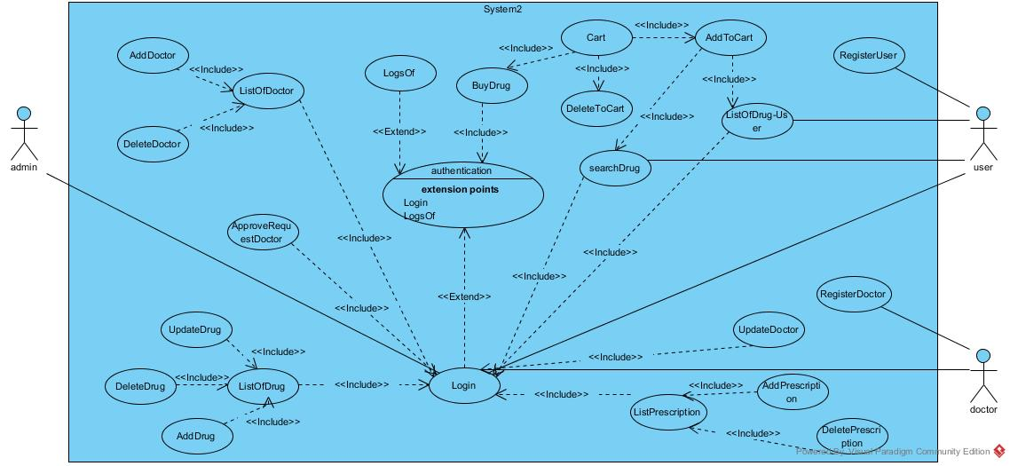

### 

### Object model

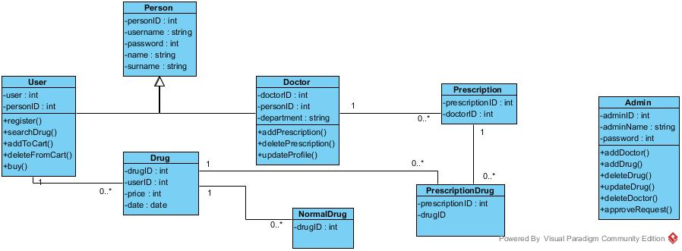

### Dynamic models

**ADMIN DYNAMIC MODEL**

Admin Authentication

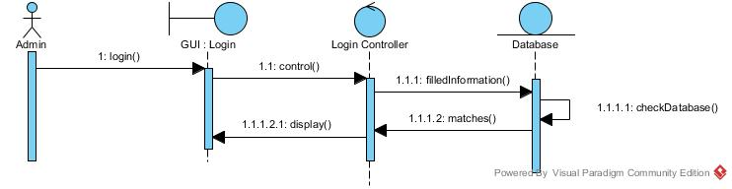

Admin Login

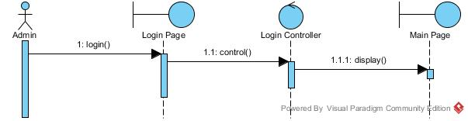

Admin List of Doctor-Add Doctor-Delete Doctor

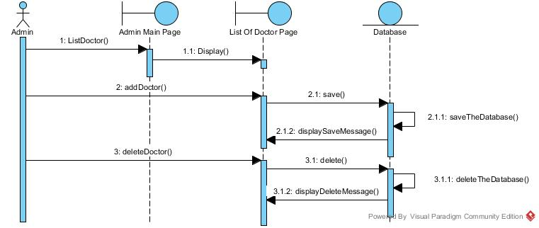

Admin Request of Doctor

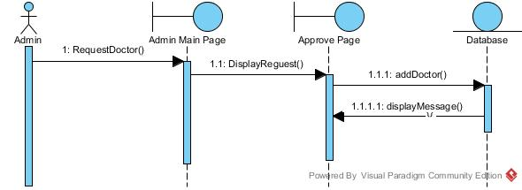

Admin List of Drug-Add Drug – Delete Drug

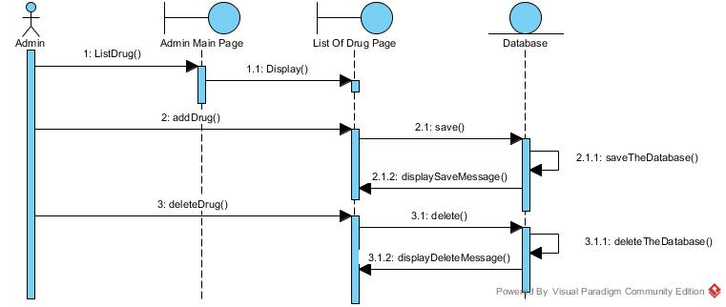

Admin-Update-Drug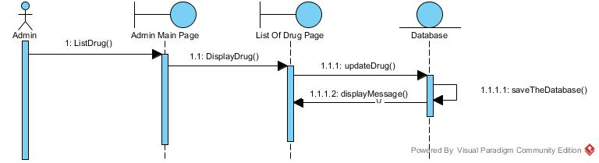

**USER DYNAMIC MODEL**

User Login

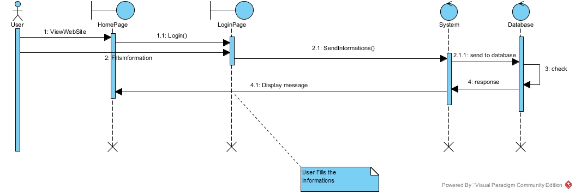

User Register

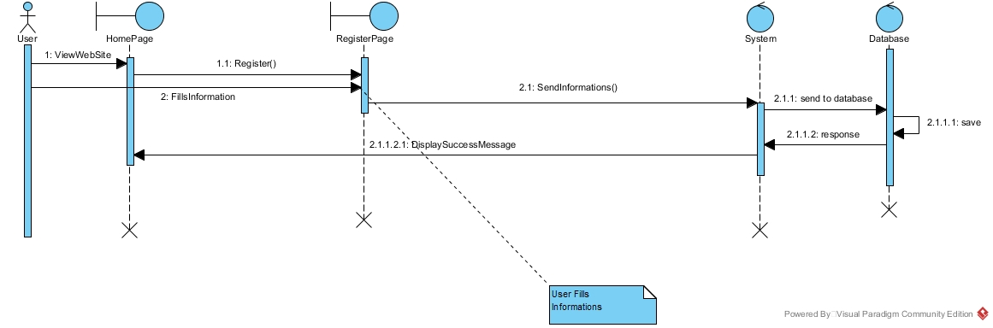

Searching Drugs

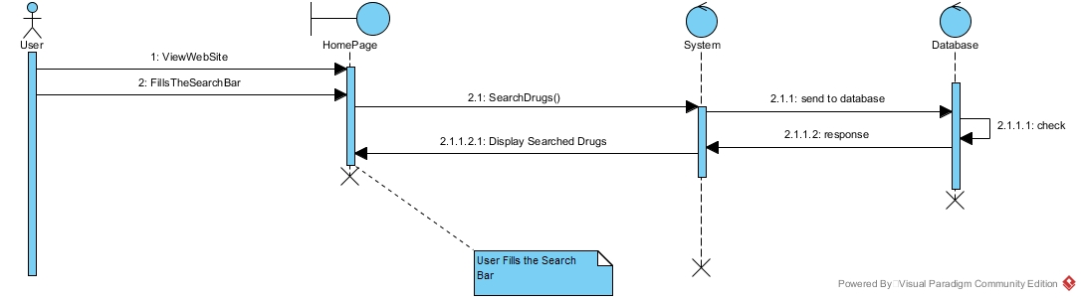

Adding-to-cart

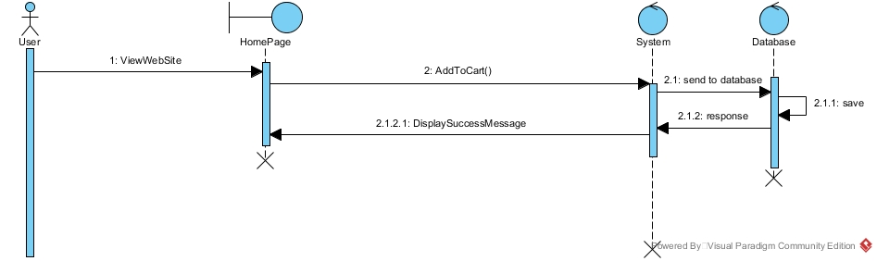

Buying the drug

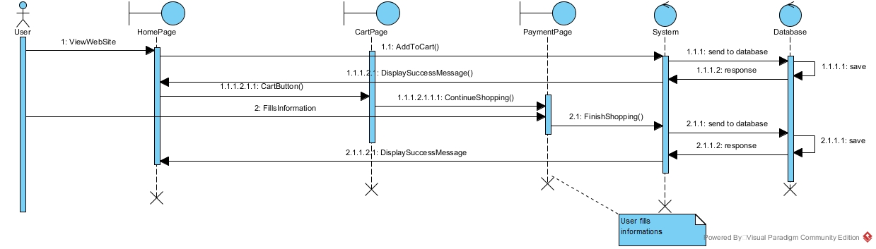

Canceling drug from cart

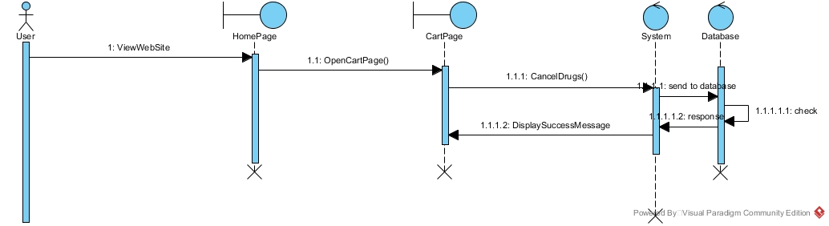

**USER DYNAMIC MODEL**

**-**Doctor Login

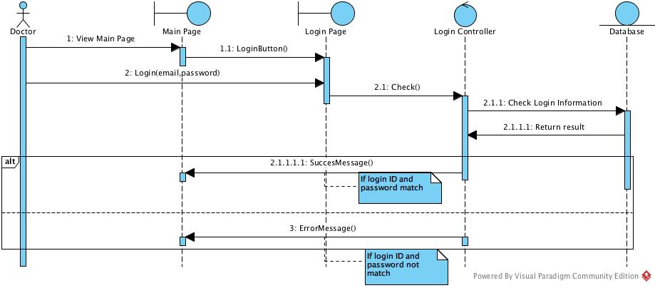

-Prescription List for Doctor

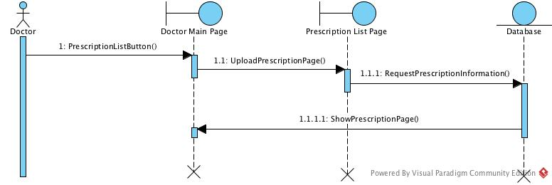

**-**Delete Prescription

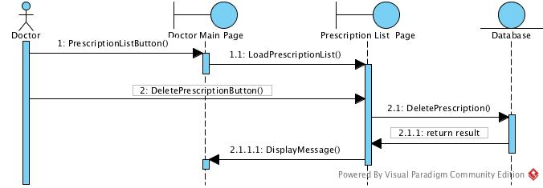

**-**Doctor Register

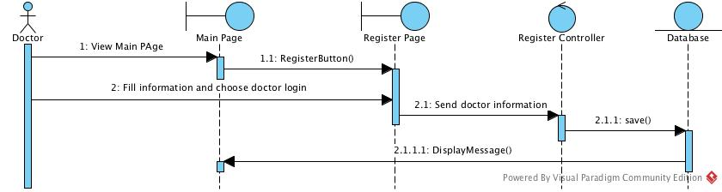

**-**Update Doctor Profile

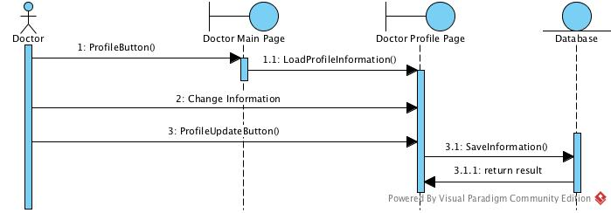

-Create Prescription

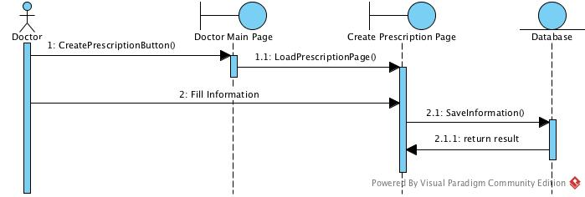

**ACTIVITY DIAGRAMS**

**Activity Diagram for Registered User**

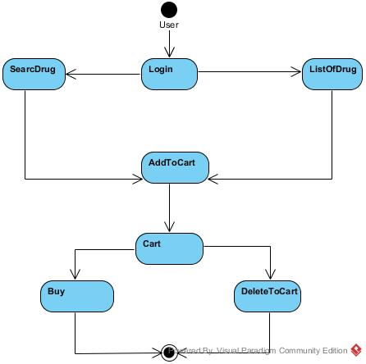

**Activity Diagram for Unregistered User**

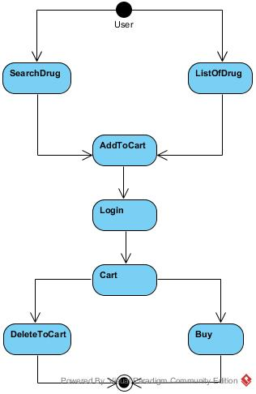

**Activity Diagram for Doctor**

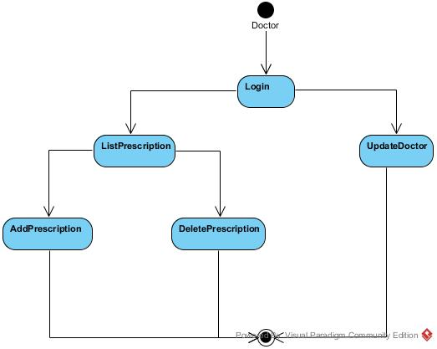

**Activity Diagram for Admin**

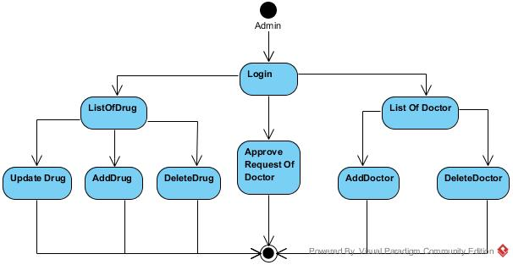

Register For Doctor And User

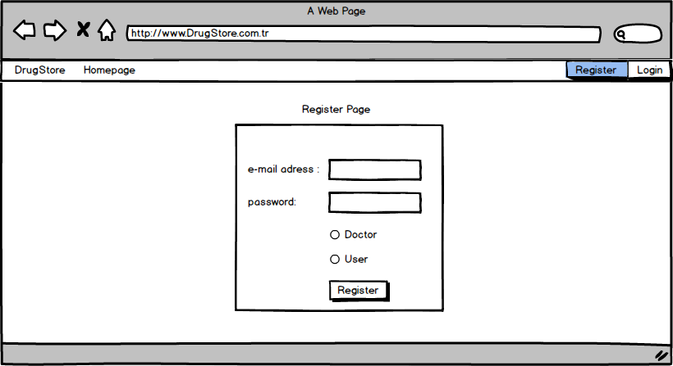

-Login For All Actor

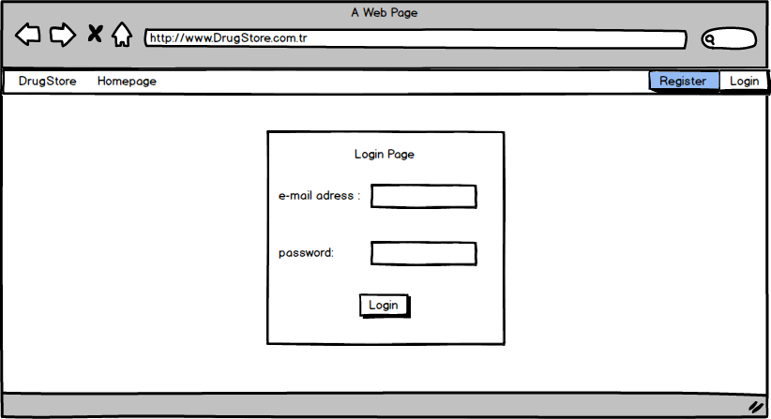

-Finish Shopping For User

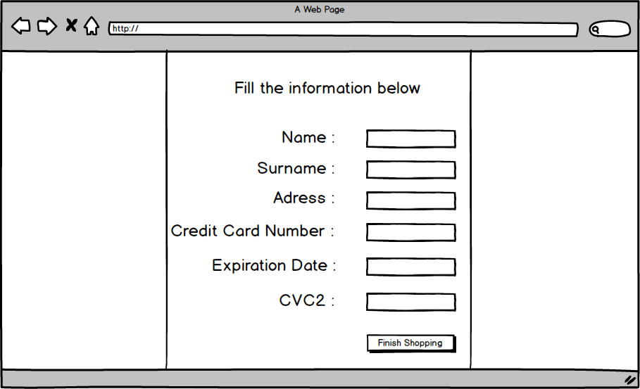

-Main Page For User

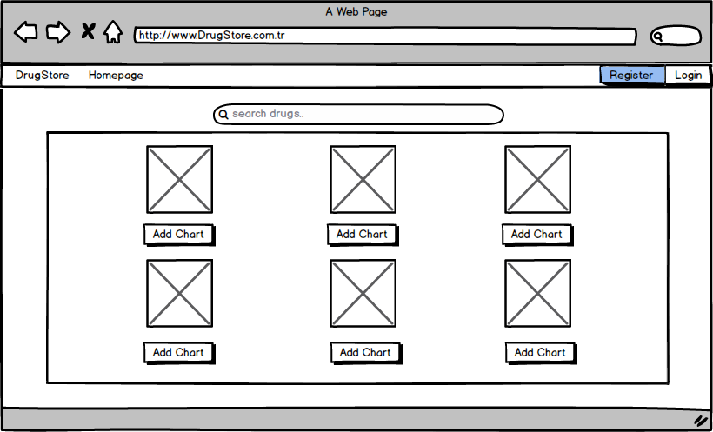

-Cart For User

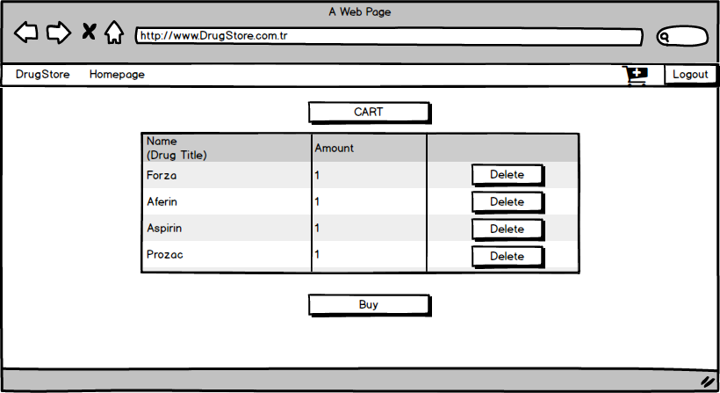

-Prescription For User

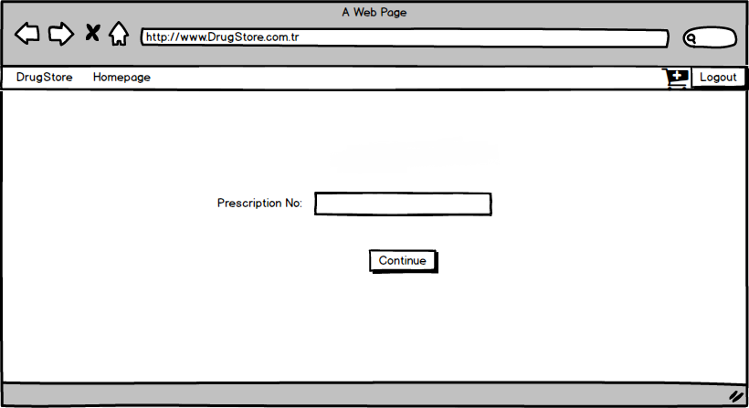

-Admin Main

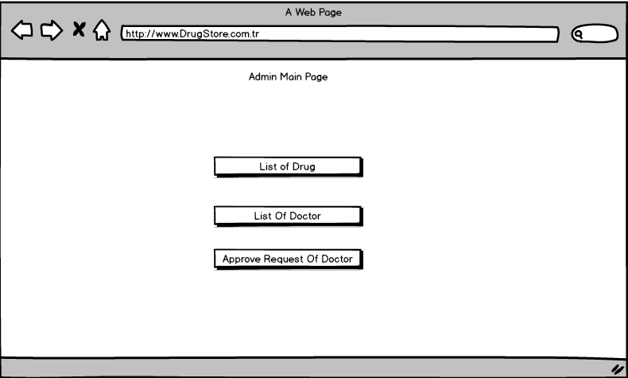

-Admin List Of Doctor

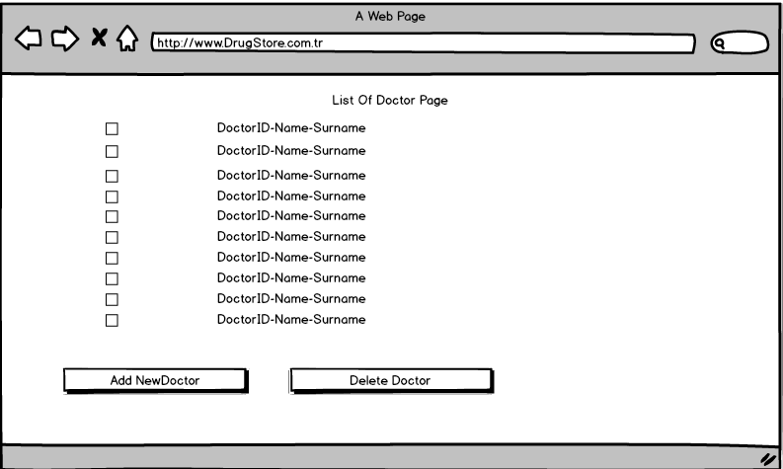

**-**Admin List Of Drug

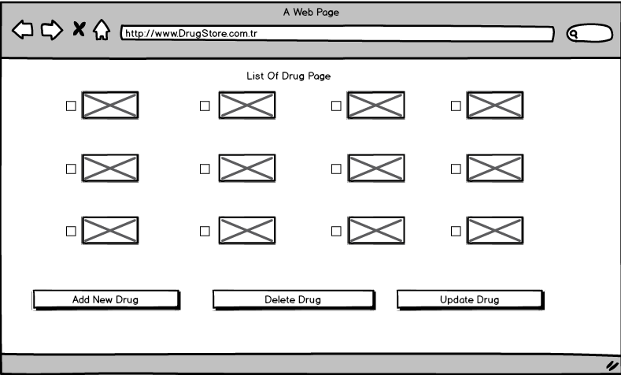

-Request Page For Admin

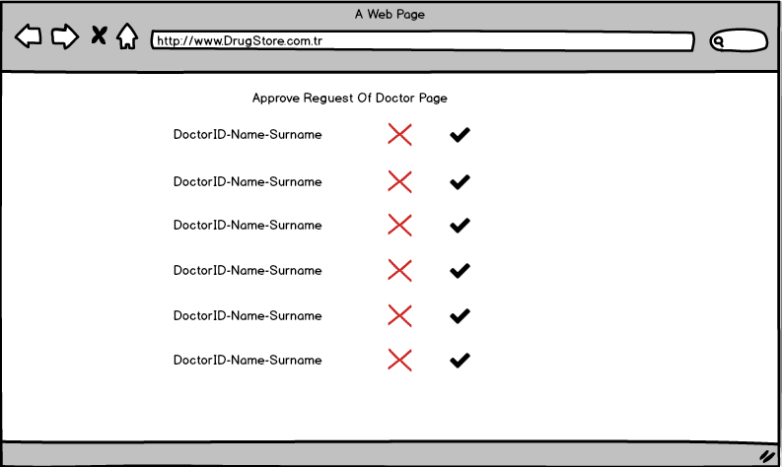

-Doctor Main Page

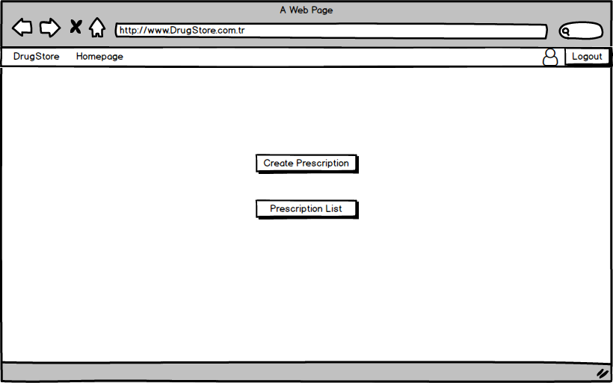

**-**Doctor Prescription List Page

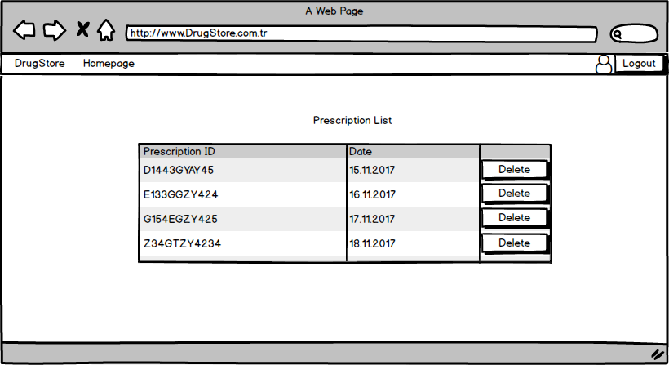

-Doctor Create Prescription

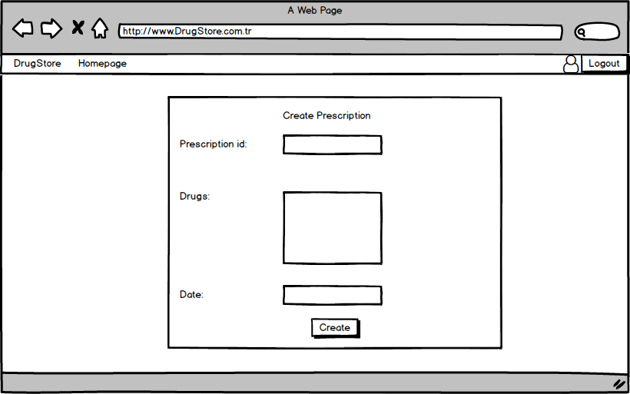

-Doctor Update Profile

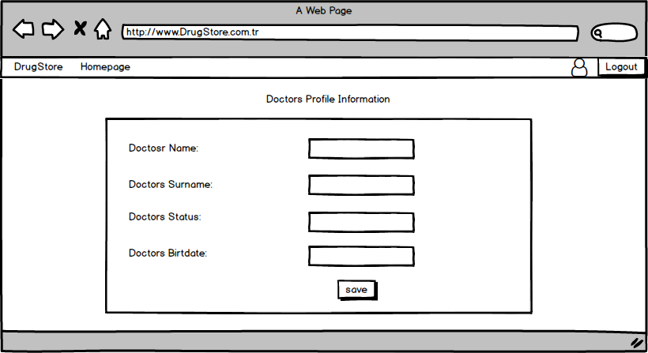

## Project Schedule

**GANTT CHART OF ONLINE DRUGSTORE SYSTEM**

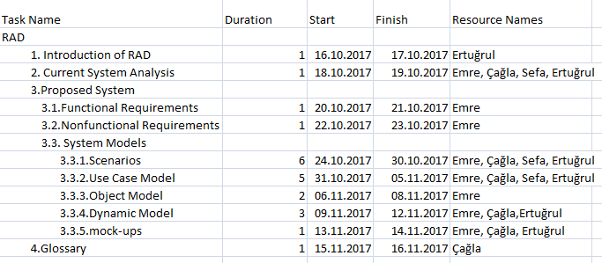

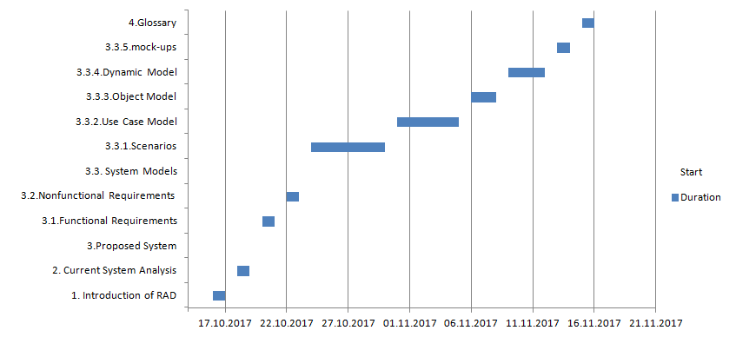

# Glossary

**Admin:**  Admin is the person who can check the system vulnerabilities.

**User:** User can buy medication without going to the pharmacy.

**Doctor:** Person who enters the prescription number for selling prescription drugs to people.

**Online Drugstore Application:** People use this web application for buy the drug.

**Use Case:** A description of an interaction between an actor and a system that results in an outcome that provides value to the actor.

**Use Case Diagram:** An analysis model that identifies the actors who can interact with a system to accomplish valuable goals and the various use cases that each actor will perform.

**Sequence Diagram:** Sequence diagrams describe interactions among classes in terms of an exchange of messages over time. They're also called event diagrams. A sequence diagram is a good way to visualize and validate various runtime scenarios. These can help to predict how a system will behave and to discover responsibilities a class may need to have in the process of modeling a new system. [2]

**Scenario**: Scenario: A description of a specific interaction between a user and a system to accomplish some goal. An instance of usage of the system. Often presented in the form of a story.

**Class:** A description of a set of objects having common properties and behaviors, which typically correspond to real-world items (persons, places, or things) in the business or problem domain.

**Nonfunctional Requirement:** An user visible constraint on the system. Nonfunctional requirements describe user visible aspects of the system that are not directly related with the functionality of the system.

**Functional Requirement:** An area of functionality the system must support. The functional requirements describe the interactions between actors and the system independent of the realization of the system.

**Analysis:** An activity during which developers ensure that the system requirements are correct, complete, consistent, unambiguous, and realistic.

**Authentication:** The process of associating a person with access rights.

**Class diagram:** UML notation representing the structure of the system in terms of objects, classes, attributes, operations, and associations. Class diagrams are used to represent object models during development.

# References

**[1]** **https://theonlinedrugstore.com/**

[2]https://www.smartdraw.com/sequence-diagram/#whatisSequenceDiagram

[3]<http://www.cs.fsu.edu/~lacher/courses/COP3331/rad.html>

**[4]**[**https://www.guru99.com/learn-software-requirements-analysis-with-case-study.html**](https://www.guru99.com/learn-software-requirements-analysis-with-case-study.html)